KATE SCHWARTZ PHYSICAL THERAPY, LLC

PATIENT RECORD FORM AND AGREEMENT

DATE_______________________DATE OF INJURY_____________________ DATE OF BIRTH___________________

PATIENT’S NAME________________________________________________MALE/FEMALE_____________________

_________________________________________________________________________________________________
ADDRESS CITY STATE ZIP

PHONE: HOME______________________________WORK______________________CELL______________________

PRIMARY CARE DOCTOR_______________________________REFERRING DOCTOR_________________________

HAVE YOU HAD PHYSICAL THERAPY IN THE PAST? _______________WHEN?______________________________

Chiropractic – Occupational Therapy – Speech? _______________________________WHEN?____________________

SOCIAL SECURITY NUMBER (for billing purposes)_______________________________________________________

EMPLOYER______________________________________EMPLOYER PHONE________________________________

EMPLOYER ADDRESS_______________________________________ OCCUPATION: _________________________

IS PRIMARY INSURANCE AUTO INSURANCE?_____________________WORKMAN’S COMP?____________________

DO YOU HAVE AN ATTORNEY INVOLVED WITH YOUR INJURY?__________________________________________

IF YES, PLEASE LIST NAME, ADDRESS, and PHONE ____________________________________________________

_________________________________________________________________________________________________

PRIMARY INSURANCE CO._____________________________SUBSCRIBER'S NAME: _________________________

SUBSCRIBER'S DATE OF BIRTH__________________RELATIONSHIP TO SUBSCRIBER_______________________

SECONDARY INSURANCE COMPANY_________________________________________________________________

ARE YOU AWARE OF YOUR PHYSICAL THERAPY BENEFITS ?____________________________________________

IF NO, PLEASE INQUIRE WITH ADMINISTRATIVE STAFF

PLEASE NOTE, $40.00 WILL BE BILLED TO YOUR ACCOUNT IF OUR OFFICE IS NOT NOTIFIED OF YOUR CANCELLATION WITHOUT 24 HOURS NOTICE.
DO YOU UNDERSTAND THIS FINANCIAL RESPONSIBILITY ? _____________________________________________

Your medical insurance contract is between you and your carrier. Our office will submit claims to your insurance carrier. You are responsible for any copay, coinsurance, deductible, medical supplies or modality not covered by your insurance company. Copay is due each visit. Referrals & authorizations for Physical Therapy are the patient’s responsibility.

I understand I am responsible for all bills incurred while receiving physical therapy, including those charges not covered by my insurance. I authorize the use of this form on all insurance submissions. I authorize release of information to all my insurance cos. I authorize my physical therapist to act as my agent in helping me obtain payment from my insurance co. I authorize payment direct to my physical therapist. I permit a copy of this authorization to be used in place of the original.

*May we contact you and/or leave messages about your appointments at phone numbers listed? ______________

SIGNATURE:____________________________________________________DATE: ____________________________

Name: ________________________ D.O.B. _____________________Date: _______________

Height:_________ Weight:_____________ Age:_____________R/L Handed:_______________

Occupation and/or school:_________________________________________________________

Describe your problems/pain beginning with the most bothersome to the least:
1)______________________________________________________________________
2)______________________________________________________________________
3)______________________________________________________________________

Please list operations/surgeries you've had and include dates:
_______________________________________________________________________
_______________________________________________________________________
_______________________________________________________________________

Please list any medications you are currently taking:
_______________________________________________________________________
_______________________________________________________________________

How did the present pain or injury begin? ____________________________________________ ______________________________________________________________________________
When? _______________________________________________________________________

Have you had any special tests done? X-rays, MRI, CT Scan, EMG, other? ______________________________________________________________________________

Where is your pain/symptoms?_____________________________________________________
______________________________________________________________________________

Are symptoms getting worse, getting better or staying the same? __________________________

What specifically increases your pain?_______________________________________________

What specifically decreases your pain?_______________________________________________

Are your symptoms constant? ________ intermittent? __________ Related to Activity? _______

What is your pain intensity from best to worst? (rating 1-10)?
(No pain)_____________________________________________________(Most pain)
best average worst

Have you had anything like this before? Explain________________________________________________________________________
________________________________________________________________________

Are you currently working? (please circle):
full-time part-time modified duty unemployed disability retired

Days missed at work because of injury?__________________ Out of Work Date?___________

Are there any restrictions set by your doctor? yes no Explain:___________________________

How does the problem interfere with your ability to work? _______________________________

Please state the maximum amount of time you tolerate each of the following activities:
Sitting _______ Standing _______Walking ______Driving ________Passenger Driving _______
How are you at night? ____________ morning? ___________ late in the day? _______________

PLEASE INDICATE ON THE DRAWING BELOW THE LOCATION OF YOUR SYMPTOMS
P – Pain N – Numbness T- Tingling B – Burning A - Achiness

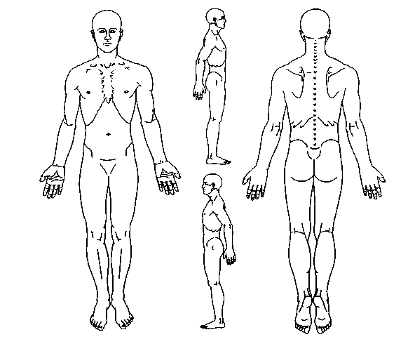

Please check as many of the following health problems that you now have or have had:

Anemia or Blood Disease ___ Stomach/Intestinal Trouble ___ Smoker (Y/N) ________
Heart Trouble/Murmur ___ Liver/Gallbladder Disease ___ How much day ________
High Blood Pressure ___ Hernia ___ How long (yrs) ________
Chest Pain/Angina ___ Diabetes/Thyroid Disease ___
Shortness of Breath ___ Sugar/Protein in Urine ___
Lung Disease ___ Kidney/Bladder Trouble ___ Do you drink Alcohol? __
Allergy/Hay Fever/Asthma ___ Headaches/Migraine ___ Beer/Wine? ___________
Eye Trouble ___ Dizziness/Fainting ___ How much day/wk? ____
Deafness/Ear Trouble ___ Nervousness/Mental Illness ___
Major Illness ___ Paralysis/Nerve Disease ___ Do you exercise regularly
Varicose Veins/Leg Sores ___ Broken Bones ___ (at least 3 times a week)
Cancer/Tumor/Cyst ___ Joint or Back Injury ___ YES NO
Bone/Joint Disease ___ Arthritis/Bursitis/Ganglion ___ Doing what? __________
Back/Disc problems ___ Recent Weight Loss/Gain ___
Amputation Foot/Leg/Arm ___ Loss of Sight ___ Are you pregnant now? __
Multiple Sclerosis ___ Cerebral Palsy ___ Ages of children _______
Head Injury ___ Parkinson’s Disease ___ (if any)
Seizures/Epilepsy ___ Stroke ___
Chronic Osteomylitis ___ Tuberculosis ___
Phlebitis ___ Hardening of Blood Vessels ___
Pacemaker ___ Osteoporosis ___
Fibromyalgia ___ Anxiety/Depression ___

Describe your major medical problems: ______________________________________________________ ______________________________________________________________________________________

